**Practical - 1**

**Aim:**

Introduce the basics of the Python language, including history, versions, and features.

**Q1:** History of Python

**Ans:**

Python was created by Guido van Rossum in the late 1980s (at CWI in the Netherlands) and first released in February 1991 (as version 0.9.1). The naming of the language was not inspired by the snake but by the BBC comedy series Monty Python’s Flying Circus, as van Rossum wanted a name that was short, unique, and slightly mysterious, Python was designed as a successor to the ABC language, emphasizing readable syntax and ease of use. Its development was led by van Rossum (the “Benevolent Dictator for Life” until 2018), and the language has since grown through community contributions. Over time, Python’s scope expanded to include features like list comprehensions, garbage collection, and Unicode support in Python 2.0 (released October 2000), and a major backwards-incompatible redesign with Python 3.0 (released December 2008). Python 2.7.18 (April 2020) was the final release of the 2.x series. Today Python 3.x is the standard: as of late 2025 the latest stable release is Python 3.14.2 (Oct 2025), with older 3.x versions in security support.

The evolution of Python is characterized by its transition through three major version lines, each introducing significant shifts in syntax and capabilities while maintaining a core philosophy of simplicity, readability, and versatility.

**The Early Era and Python 1.x**

The initial publication of Python version 0.9 occurred in 1991, setting the stage for the first major stable release. Python 1.0 was subsequently released in January 1994. During its inception and early years, the language was designed to be a high-level, human-understandable alternative to low-level machine and assembly languages. Guido van Rossum built Python by borrowing features from several existing programming languages: functional programming and syntax were influenced by C and ABC, object-oriented programming (OOP) features were borrowed from C++, and scripting and modular features were taken from Perl, Shell script, and Modula-3. This multi-paradigm approach allowed Python to be functional, object-oriented, and modular simultaneously, dividing code into small, manageable modules.

**Python 2.x: The Legacy Line**

Python 2.0 was released in October 2000, marking a decade of growth and broader adoption in the industry. Version 2.x introduced many of the features that would eventually make Python one of the most popular languages in the world, leading to its heavy use by major companies like Google, NASA, and Industrial Lights and Magic.

**Key characteristics of the 2.x line include:**

* **Print as a Statement:** In Python 2, print was treated as a statement rather than a function, meaning it was written as print "message" without parentheses.
* **Input Handling:** The language used raw_input() to capture user input as a string and input() to evaluate the input immediately.
* **Division Behavior:** Python 2 performed "truncated" or floor division by default when dealing with integers; for example, 7/2 would yield 3 instead of 3.5.
* **String Encoding:** The implicit string type in Python 2 was ASCII.
* **Iterators:** It utilized the xrange() function, which returned an object that worked similarly to a Java iterator, alongside the standard range() function which returned a list.

Python 2.7, released in the late 2000s, became the final major release of this line. While it is still seen today in older software that cannot be easily upgraded, it is considered a legacy line that receives only security patches or back-ported features rather than new major developments.

**Python 3.x: The Modern Standard**

Python 3.0 was released in December 2008 and represented a significant break from the past because it was not designed to be backwards-compatible with Python 2. This decision allowed the development team to clean up the language's syntax and remove redundancies, but it required programmers to put in significant effort to convert code between the two versions. Python 3 is the current main development line, with the latest versions reaching 3.13.1 and 3.14.2.

Major changes and new features in Python 3.x include:

* **Print as a Function:** print() became a built-in function, requiring parentheses (e.g., print("message")), which allowed for more flexible parameters like sep and end.
* **Unified Input:** The raw_input() function was removed, and input() was modified to automatically treat all user input as a string.
* **Unicode Support:** Python 3 uses Unicode as the implicit string type by default, enabling better handling of non-ASCII characters like Greek letters or mathematical symbols.
* **Enhanced Division:** Division was changed to automatically convert results to decimal values (floats); therefore, 7/2 now correctly returns 3.5.
* **Iterator Consolidation:** The xrange() function was removed, and the standard range() function was modified to behave like xrange for better memory efficiency.
* **Exception Handling:** A minor but mandatory change was made to exception handling, requiring the use of the as keyword when catching exceptions.
* **Advanced Features:** Recent iterations of Python 3 have added features like type hinting, improved Just-In-Time (JIT) improvements, and extensive support for AI, machine learning, and data science through libraries like NumPy.

**Timeline of Python’s history include:**

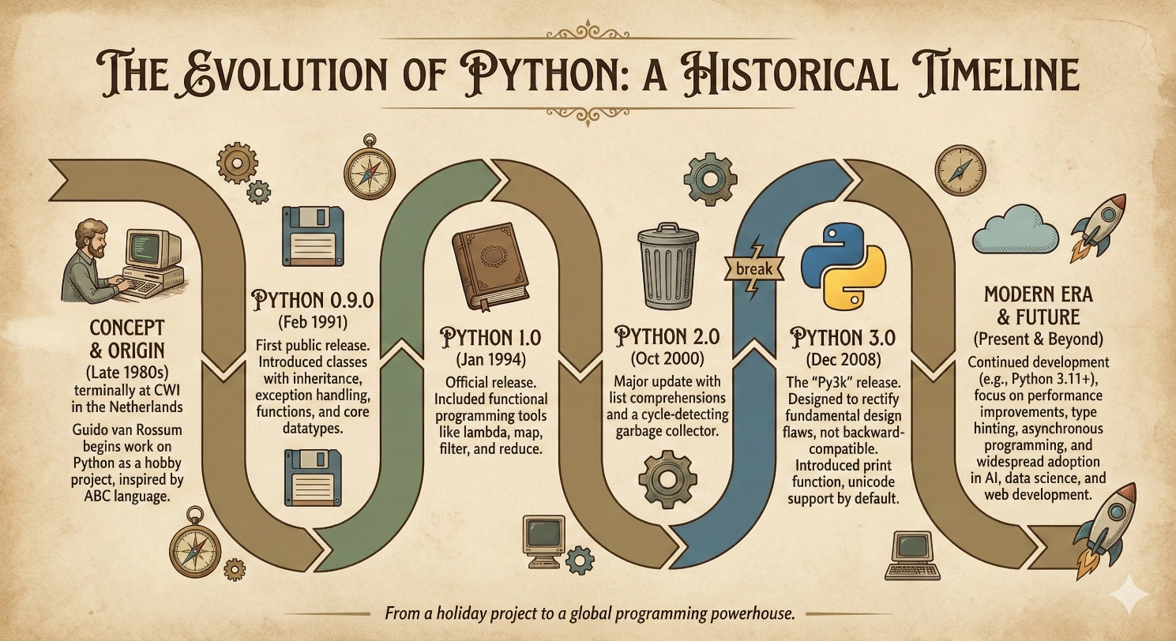

* **1991 – Python 0.9.1:** First public release (Feb 1991) including classes, exception handling, functions, and the core datatypes (list, dict, str)
* **1994 – Python 1.0:** Official version 1.0 released (Jan 1994), adding functional features (map, filter, reduce) and solidifying the module system
* **2000 – Python 2.0:** Released October 2000 with new features (list comprehensions, cycle-detecting garbage collector, Unicode support). The 2.x series continued up to 2.7.18 (April 2020)
* **2008 – Python 3.0:** Released December 2008 as a major overhaul (incompatible with 2.x) with improved Unicode, print function, and other changes. Python 3 has since become the focus of development.
* **2025 – Python 3.14:** The current stable series (Python 3.14.2 released Oct 2025). Python 3.10–3.14 are actively supported, while Python 3.15 is in development.

**Language Evolution and Philosophy**

Throughout its history, Python has evolved from being a simple scripting tool into a "glue" language that can combine components written in different languages like C++ or Java. Its design remains centered on "Less Code, More Power," with Python programs typically being 3 to 5 times shorter than equivalent Java programs and 5 to 10 times shorter than C++ programs. Unlike "statically typed" languages like C or Java, where variable types must be declared at compile-time, Python remains "dynamically typed," checking variable types at run-time. This flexibility, combined with its mandatory indentation for code blocks, has ensured that Python remains a highly recommended language for beginners while being powerful enough for complex industrial applications.

**Q2:** Differentiate compiler and interpreter

**Ans:**Compilers and interpreters are the primary tools used to translate high-level, human-understandable programming languages into low-level machine code that a computer's central processing unit can execute. While both serve the same ultimate goal of code translation, they differ fundamentally in their processing methods, execution timing, and error-handling capabilities.

**Fundamental Processing and Input Handling**

The core distinction between the two lies in how they read the source code: a compiler takes the entire program as a single input and converts it into machine code all at once. Conversely, an interpreter takes just one line of the program as input at a time and converts that specific instruction into machine code before moving to the next. Because a compiler processes the whole file, it can analyze the logic across the entire application before any execution begins. An interpreter, however, operates line-by-line, meaning it must translate each instruction as it encounters it during the program's run.

**Translation Timing and Intermediate Products**

For a compiled language, the translation phase is a distinct step that must be completed entirely before the program can be run. This process typically generates an intermediate product known as an object file (.obj), which contains the machine-readable version of the code. Interpreters do not create an intermediate object code file; instead, they perform the translation and execution simultaneously. In the case of Python, the interpreter creates "byte-code," which is a platform-independent format that is then translated into something the host operating system can understand by a language-specific virtual machine.

**Execution Speed and Optimization**

Programs that are compiled generally offer faster execution of control statements and overall higher performance compared to those that are interpreted. This is because the compiler has the opportunity to optimize the code for the specific hardware environment during the initial compilation step. Interpreted languages are often slower because the computer must perform translation tasks while the program is running, which adds overhead. For example, in a language like Python, the runtime must work harder to inspect objects to determine their types before performing operations, whereas a compiled language like Java handles variable types and declarations during the build process.

**Memory Usage**

Compilers and interpreters have different impacts on system resources: a compiler requires more memory during its operation because it must create and store the resulting object code files. Interpreters are more memory-efficient in this regard because they bypass the creation of intermediate object files and execute instructions directly in sequence.

**Error Detection and Debugging**

The error-reporting mechanisms of these two tools create very different workflows for developers:

* **Compiler:** It identifies and displays errors only after the entire program has been read and analyzed. This means a programmer may have to wait for a lengthy compilation process to finish before seeing a list of syntax or logic errors.
* **Interpreter:** It detects and displays errors immediately after each individual instruction is read. This behavior makes debugging much easier and more intuitive, as the programmer is notified of the exact line where a failure occurred as soon as the interpreter reaches it.

**The Development Lifecycle**

The choice between a compiler and an interpreter significantly affects the speed of software development:

* **The Compiled Cycle:** Developers often find themselves in a "compile-fix-compile" loop, which can take minutes or even hours depending on the size of the project. While compilers catch many errors before runtime, the process of waiting for the code to build can be tedious.
* **The Interpreted Cycle:** Languages like Python facilitate a very rapid "edit-test-debug" cycle. Because there is no separate compilation step, the code can be run as often as necessary while fixing errors, making the development process much faster. For many modern software products, minimizing developer time is considered more important than maximizing computer processing speed.

**Portability and System Dependencies**

Compiled machine code is usually "portable" in theory but must be recompiled from raw source code for every unique computer system or target operating system. This means the programmer must generate different versions of the compiled code for each environment they wish to support. Interpreted languages are truly "system agnostic" because the intermediate byte-code they produce can run on any operating system that has the appropriate virtual machine installed. The programmer does not need to perform any special steps to make the software run across different platforms.

**Examples of Each**

Commonly used compiled languages include C, C++, and Java. Languages that traditionally rely on an interpreter include BASIC, Python, PHP, and JavaScript. Some modern languages, such as Java, use a hybrid approach where source code is compiled into byte-code and then processed by an interpreter or virtual machine to ensure cross-platform compatibility.

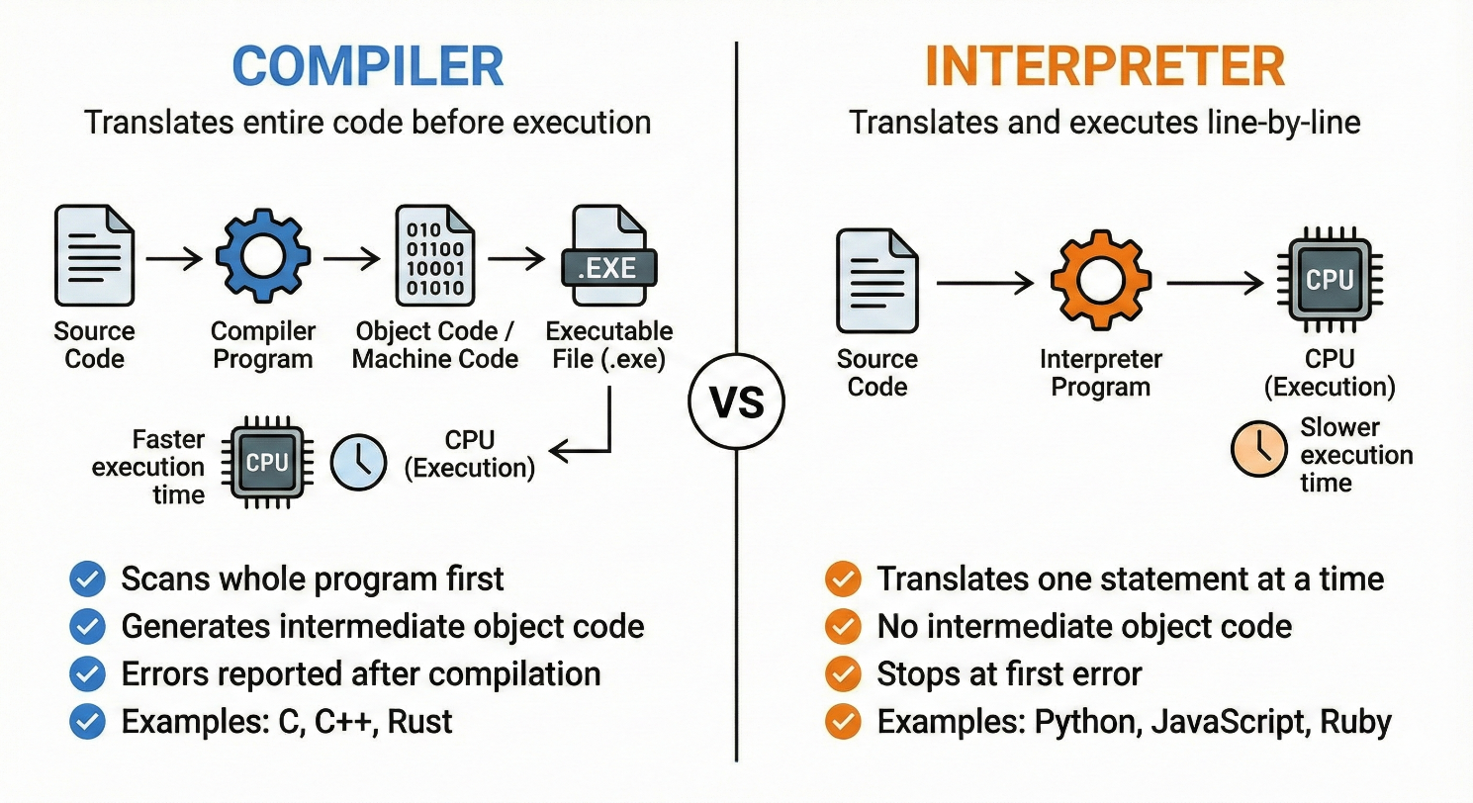

**Tabular From:**

|  |  |  |
| --- | --- | --- |
| **Feature** | **Compiler** | **Interpreter** |
| *Input Processing Method* | A compiler processes the entire source code of a program as a single unit before any translation begins. It reads the whole file to understand the logic and structure of the application. | An interpreter processes the program sequentially, taking only one line of code or a single instruction as input at a time. |
| *Intermediate Code Generation* | The compilation process usually generates an intermediate product known as an object file (with a .obj extension), which contains the machine code version of the program. | Interpreters generally do not create permanent intermediate object code files. For example, Python’s interpreter generates "byte-code" in memory, which is then handled by a virtual machine. |
| *Execution Timing* | Translation is a separate, distinct phase that must be fully completed before the program can be executed. | Translation and execution occur simultaneously; the interpreter translates a line and immediately executes it before moving to the next. |
| *Performance and Speed* | Compiled programs typically offer faster execution of control statements because the code is pre-optimized for the specific hardware environment during the compilation step, | Execution is generally slower because the computer must spend processing power on translation tasks while the program is actively running. |
| *Memory Usage* | Compilers require significant memory resources during operation because they must generate and store the resulting intermediate object code files. | Interpreters are more memory-efficient as they do not need to create or store large intermediate object code files on the disk. |
| *Error Detection and Reporting* | Errors are only identified and displayed after the compiler has finished reading and analyzing the entire program, this may lead to a long list of errors presented all at once. | Errors are detected and reported immediately after each instruction is read. This makes it easier to pinpoint the exact line where a failure occurred during runtime. |
| *Development Lifecycle* | Developers follow a "compile-fix-compile" cycle, which can be time-consuming because they must wait for the entire program to rebuild after every minor fix. | Interpreters facilitate a rapid "edit-test-debug" cycle because there is no separate compilation step, allowing the code to be run immediately after changes. |
| *Portability and Dependencies* | Machine code produced by a compiler is specific to a particular computer system or operating system and must be recompiled for every new target environment. | Interpreted languages are often "system agnostic" because the byte-code they produce can run on any OS that has the required language-specific virtual machine installed. |
| *Programming Language Examples* | Common examples include C, C++, and Java | Common examples include BASIC, Python, PHP, and JavaScript. |

**Summary**

* **Compiler:** Translates the entire program to machine code in one go, producing an executable. Results in faster runtime performance (since machine code runs natively), but requires a complete compile step and recompilation on changes. Examples of compiled languages include C, C++, and C#.
* **Interpreter:** Translates and executes code statement by statement at runtime. No separate compile step is needed. This allows quick testing and debugging (errors show up immediately), but each run may be slower. The Python interpreter (CPython) works this way, as do languages like Ruby and Perl.

**Q3:** What types of applications can be developed by using Python?

**Ans:**

Python’s versatility as a high-level, human-understandable language makes it useful across many different domains. Because it is designed to be a general-purpose tool, it allows developers to focus on the logic of their ideas rather than complex machine-level syntax.

**Common application areas include:**

* **Web & Internet Development:** Python is a staple for back-end or server-side development, utilizing powerful frameworks like Django and Flask to build secure and scalable web platforms. The sources note that its ecosystem includes a wide range of additional frameworks such as Pyramid, Bottle, Tornado, Litestar, web2py, and CMS systems like Plone or django CMS. Its extensive standard library and PyPI modules further support various web protocols, including HTML, XML, JSON, email, and FTP.
* **Scientific & Numeric Computing:** Python is a preferred tool for researchers and engineers performing complex scientific simulations and data work. Libraries such as SciPy are used for math and engineering, while NumPy provides the foundation for handling numeric arrays and matrix calculations. Other essential tools for research include Pandas for data analysis and IPython for an enhanced interactive shell environment. Python’s broad ecosystem, including tools like matplotlib, scikit-learn, and TensorFlow, enables advanced work in statistics, simulation, and machine learning.
* **Education:** The language's elegant simplicity and mandatory indentation for readability make it highly recommended as a first language for learning to program. Python code is typically 3 to 5 times shorter than equivalent Java programs and 5 to 10 times shorter than C++, allowing students to write complex code in a much simpler way. It is one of the most popular languages taught in colleges and universities today.
* **Desktop GUI Applications:** Python supports the creation of user-facing software and graphical user interfaces through various toolkits. The standard library includes Tkinter, but developers often use more advanced third-party frameworks like PyQt, PySide, or wxPython for native OS experiences. Kivy is specifically highlighted for creating cross-platform interfaces that work on desktop, mobile, and touch devices.
* **Software Development & Scripting:** Python is frequently used as a "glue" language to combine and coordinate components written in different languages like C, C++, or Java. It facilitates a rapid "edit-test-debug" cycle, making it the ideal tool for initial application prototyping before a design is "hardened" in a lower-level language. Professional software tools built with Python include the Buildbot CI server, tracking systems like Trac and Roundup(project management/bug tracking)., and system administration tools like Ansible, Salt, and OpenStack.
* **Business & Enterprise:** Python powers many mission-critical business applications due to its rapid development speed and wide library support. While the sources do not explicitly name "Odoo" or "Tryton," they confirm that Python is heavily used in industry by major organizations such as Google, NASA, Rackspace, and the Department of Defense for a wide range of complex tasks. Its ability to act as a multi-paradigm language—supporting functional, object-oriented, and modular programming—allows it to adapt to diverse enterprise needs.
* **Game Development:** Python is used in the gaming industry to create interactive environments and handle game logic. It allows for the simulation of real-world physics and the modeling of complex visual outputs. Many developers use Python to provide scripting interfaces for end-users, such as "modding" communities in video games, which allow for customization without modifying the core source code.
* **Internet of Things (IoT):** For the realm of connected devices, Python is used to program microcontrollers and develop "smart" hardware applications. Versions like MicroPython are specifically designed to run in these constrained hardware environments, enabling robotics and IoT innovation.
* **Networking:** Python is utilized to develop networking applications and tools for database interaction. Its ability to integrate systems more effectively allows it to handle data transfers, network connections, and communication between disparate hardware components.

Each of these domains is well-supported by Python’s large standard library and the extensive collection of over 150,000 third-party modules available through the Python Package Index (PyPI).

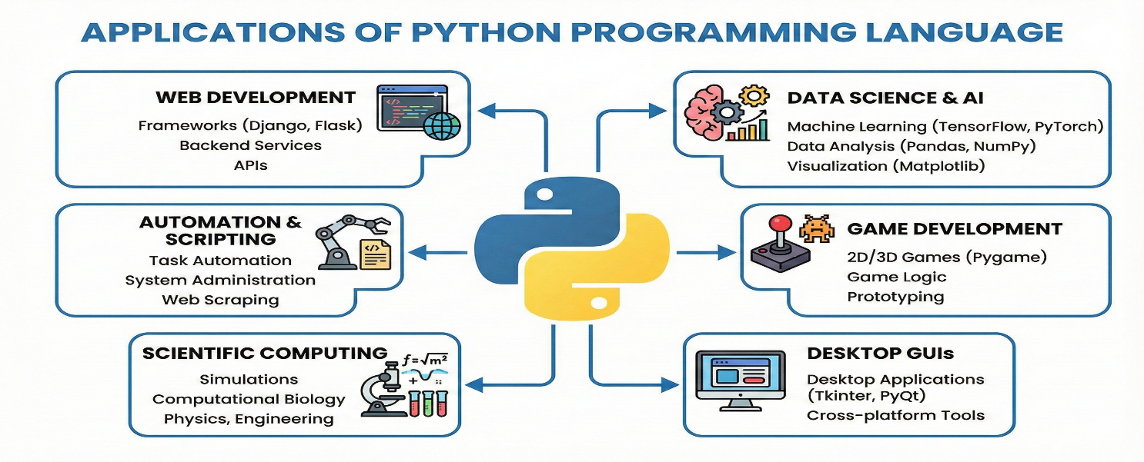

**Q4:** List down Python versions.

**Ans:**

**The Early Era and Python 1.x**

The initial publication of Python version 0.9 occurred in 1991, setting the stage for the first major stable release. Python 1.0 was subsequently released in January 1994. During its inception and early years, the language was designed to be a high-level, human-understandable alternative to low-level machine and assembly languages. Guido van Rossum built Python by borrowing features from several existing programming languages: functional programming and syntax were influenced by C and ABC, object-oriented programming (OOP) features were borrowed from C++, and scripting and modular features were taken from Perl, Shell script, and Modula-3. This multi-paradigm approach allowed Python to be functional, object-oriented, and modular simultaneously, dividing code into small, manageable modules.

**Python 2.x: The Legacy Line**

Python 2.0 was released in October 2000, marking a decade of growth and broader adoption in the industry. Version 2.x introduced many of the features that would eventually make Python one of the most popular languages in the world, leading to its heavy use by major companies like Google, NASA, and Industrial Lights and Magic.

**Key characteristics of the 2.x line include:**

* **Print as a Statement:** In Python 2, print was treated as a statement rather than a function, meaning it was written as print "message" without parentheses.
* **Input Handling:** The language used raw_input() to capture user input as a string and input() to evaluate the input immediately.
* **Division Behavior:** Python 2 performed "truncated" or floor division by default when dealing with integers; for example, 7/2 would yield 3 instead of 3.5.
* **String Encoding:** The implicit string type in Python 2 was ASCII.
* **Iterators:** It utilized the xrange() function, which returned an object that worked similarly to a Java iterator, alongside the standard range() function which returned a list.

Python 2.7, released in the late 2000s, became the final major release of this line. While it is still seen today in older software that cannot be easily upgraded, it is considered a legacy line that receives only security patches or back-ported features rather than new major developments.

**Python 3.x: The Modern Standard**

Python 3.0 was released in December 2008 and represented a significant break from the past because it was not designed to be backwards-compatible with Python 2. This decision allowed the development team to clean up the language's syntax and remove redundancies, but it required programmers to put in significant effort to convert code between the two versions. Python 3 is the current main development line, with the latest versions reaching 3.13.1 and 3.14.2.

Major changes and new features in Python 3.x include:

* **Print as a Function:** print() became a built-in function, requiring parentheses (e.g., print("message")), which allowed for more flexible parameters like sep and end.
* **Unified Input:** The raw_input() function was removed, and input() was modified to automatically treat all user input as a string.
* **Unicode Support:** Python 3 uses Unicode as the implicit string type by default, enabling better handling of non-ASCII characters like Greek letters or mathematical symbols.
* **Enhanced Division:** Division was changed to automatically convert results to decimal values (floats); therefore, 7/2 now correctly returns 3.5.
* **Iterator Consolidation:** The xrange() function was removed, and the standard range() function was modified to behave like xrange for better memory efficiency.
* **Exception Handling:** A minor but mandatory change was made to exception handling, requiring the use of the as keyword when catching exceptions.
* **Advanced Features:** Recent iterations of Python 3 have added features like type hinting, improved Just-In-Time (JIT) improvements, and extensive support for AI, machine learning, and data science through libraries like NumPy.

**Timeline of Python’s history include:**

* **1991 – Python 0.9.1:** First public release (Feb 1991) including classes, exception handling, functions, and the core datatypes (list, dict, str)
* **1994 – Python 1.0:** Official version 1.0 released (Jan 1994), adding functional features (map, filter, reduce) and solidifying the module system
* **2000 – Python 2.0:** Released October 2000 with new features (list comprehensions, cycle-detecting garbage collector, Unicode support). The 2.x series continued up to 2.7.18 (April 2020)
* **2008 – Python 3.0:** Released December 2008 as a major overhaul (incompatible with 2.x) with improved Unicode, print function, and other changes. Python 3 has since become the focus of development.
* **2025 – Python 3.14:** The current stable series (Python 3.14.2 released Oct 2025). Python 3.10–3.14 are actively supported, while Python 3.15 is in development.

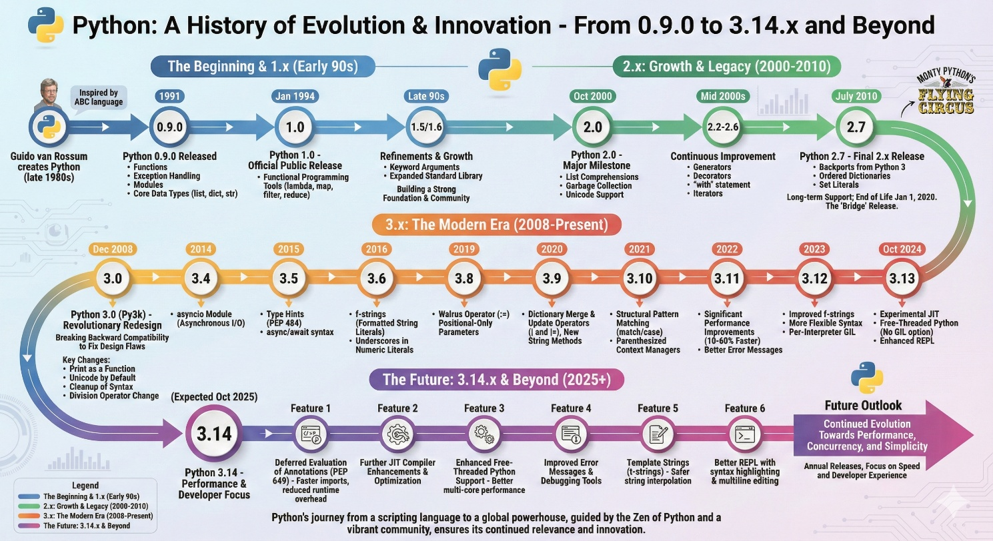

**Q5:** List out Python IDE.

**Ans:**

Many development environments support Python. Common integrated development environments (IDEs) and code editors include:

* **IDLE:** The default Python IDE bundled with CPython. A simple editor with syntax highlighting and a debugger, suitable for beginners.
* **PyCharm:** A full-featured Python IDE (from JetBrains) popular with professional developers. It offers smart code navigation, refactoring, integrated testing, and framework support. (There is a free Community Edition and a paid Professional Edition.)
* **Visual Studio Code (VS Code):** A free, lightweight editor from Microsoft. With Python extensions installed, VS Code becomes a powerful IDE with autocomplete, debugging, and Git integration. It is widely used for Python and many other languages.
* **Jupyter Notebook/Lab:** An interactive notebook environment (originally IPython) extensively used in data science. Not technically a classic IDE, but it lets you write and execute Python code blocks with rich output (charts, math, etc.) in a document.
* **Spyder:** An open-source scientific IDE (bundled with Anaconda) that resembles MATLAB. It includes an editor, interactive console, variable explorer, and plotting integration, making it good for data analysis work.
* **Eclipse + PyDev:** Eclipse is a powerful multi-language IDE. With the PyDev plugin, it supports Python development (code completion, debugging).
* **Thonny:** A simple Python IDE designed for learning and beginners. It has a debugger and a clear view of variables, making it easy to step through code.
* **Others:** Developers also use editors like Sublime Text, Atom, Vim/Neovim, Emacs, or IDEs like Wing IDE, Komodo, Eric Python IDE, etc. (These can be customized with Python plugins.)

Each of these environments offers different trade-offs (simplicity vs. features), but all support writing and running Python code.

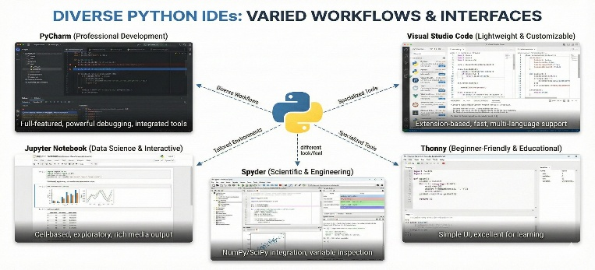

**Q6:** List out the features of Python.

**Ans:**

Python is a general-purpose, high-level programming language that was designed to prioritize human readability and developer efficiency. Its "general-purpose" designation means that it is not restricted to a single type of task; rather, it can be applied to a vast array of fields including data science, machine learning, web development, desktop applications, and the Internet of Things (IoT).

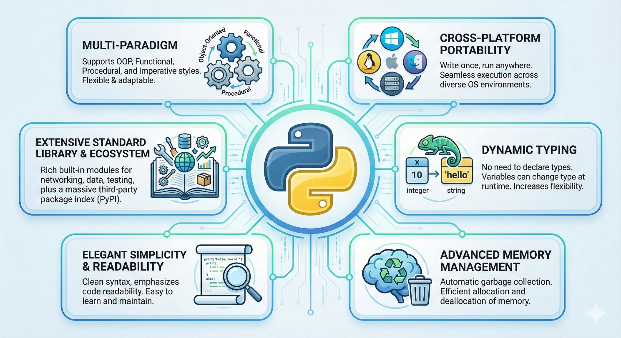

**The following is a detailed examination of the core features that define the language:**

* **High-level, Readable Syntax:** Python is a high-level general-purpose language emphasizing code readability. It uses indentation (whitespace) instead of braces for blocks, and English-like keywords, making code concise and clear.
* **Elegant Simplicity and Readability:** Python follows a philosophy often summarized as "Less Code, More Power," focusing on the logic of an idea rather than complex syntax. It is highly expressive and human-understandable, making it a recommended language for those beginning their programming journey. Python programs are significantly more concise than those written in other popular languages; for instance, a Python program is typically 3 to 5 times shorter than an equivalent Java program and 5 to 10 times shorter than one written in C++. A simple "Hello World" task requires only one line in Python, whereas Java or C might require 8 to 10 lines of boilerplate code.
* **Interpreted Execution and Rapid Development:** Unlike compiled languages like C++ or Java, Python is an interpreted scripting language. A compiler must take an entire program as input and convert it into machine code before any part of it can run, a process that can take minutes or even hours for large projects. In contrast, a Python interpreter processes code line by line, executing each instruction as it is read. This eliminates the time-consuming "compile-fix-compile" cycle, facilitating a very fast "edit-test-debug" cycle. This feature makes Python an ideal tool for initial application prototyping, allowing designs to be clarified quickly before they are potentially re-implemented in a lower-level language for optimization.
* **Dynamic Typing:** Python is a dynamically typed language, which provides immense flexibility compared to statically typed languages like C, Java, or C#. In a statically typed environment, a programmer must explicitly declare the data type of a variable (such as an integer or float) at compile-time, and that type cannot change. Python variables, however, are simply labels given to data values. The interpreter checks the type of a variable during run-time based on the value assigned to it. This allows a single variable to point to an integer at one moment and a string the next, reducing the need for prior type specification and simplifying code structure.
* **Multi-paradigm:** While developing Python, Guido van Rossum borrowed the best features from several existing languages to create a multi-paradigm tool. It supports:
  + **Object-Oriented Programming (OOP):** Borrowed from C++, this allows programs to be organized into objects containing both data and methods.
  + **Functional and Procedural Programming:** Borrowed from C, this enables a top-down approach where programs are divided into reusable functions.
  + **Modular Programming:** Borrowed from Modula-3, this allows code to be divided into small, manageable modules.
  + **Scripting:** Borrowed from Perl and Shell script, making it ideal for automation tasks.
* **Extensive Standard Library and Ecosystem:** Python features a massive standard library that provides a rich set of built-in modules and functions for rapid application development. This allows developers to perform complex tasks "right out of the box" without writing everything from scratch. Furthermore, the Python Package Index (PyPI) serves as an official repository for more than 150,000 third-party libraries, enabling specialized work in scientific computing (NumPy, SciPy), data analysis (Pandas), and artificial intelligence (TensorFlow).
* **Cross-Platform Portability:** Python is a portable, system-agnostic language. Because it uses an interpreter to create "byte-code"—a platform-independent format—it can run equally on different operating systems such as Windows, Linux, Unix, and Macintosh. Any system that has a language-specific virtual machine installed can translate this byte-code into instructions the host computer can understand, meaning a programmer does not have to perform special steps to ensure compatibility across different target environments.
* **Advanced Memory Management:** Python simplifies development by automating low-level system tasks. It includes features like dynamic memory allocation and a built-in garbage collector, which automatically reclaims memory space when an object is no longer referenced. This prevents many common errors associated with lower-level languages where memory must be managed manually by the programmer.
* **"Glue" Language Capability:** Python is uniquely suited to act as a "glue" language, which means it can combine and coordinate components written in different implementation languages. For example, performance-heavy components can be written and compiled in C or C++ and then integrated into a Python application to benefit from both the speed of compiled code and the readability of Python. This is further supported by bindings like Jython (for Java environments), IronPython (for .NET), and MicroPython (for microcontrollers).

These features (simplicity, rich libraries, portability, etc.) make Python suitable for rapid development of many kinds of programs.

**Q7:** Write advantages of Python language over other languages.

**Ans:**

Python provides several distinct advantages over other popular programming languages such as C, C++, and Java, primarily focusing on developer efficiency, readability, and versatile application.

* **Easy to Learn & Use:** Python’s clear, concise syntax is simpler than verbose languages like C++ or Java. This reduces complexity and learning time. Python code often requires fewer lines to express the same logic (e.g. a loop or conditional) compared to other languages.
* **Syntactic Conciseness and Readability:** One of Python's most significant advantages is its "Elegant Simplicity," which allows developers to accomplish tasks with far fewer lines of code than other languages. For example, a simple "Hello World" program in Python requires only a single line, whereas Java or C typically require between eight and ten lines of boilerplate code, including class and main method declarations. Generally, Python programs are estimated to be 3 to 5 times shorter than equivalent Java programs and 5 to 10 times shorter than those written in C++. This brevity is enhanced by Python's use of mandatory indentation. While other C-based languages use brackets and semicolons to show code grouping or end-of-line termination, Python uses white space as a syntactically significant indicator of where each code block starts and ends. This forces the programmer to maintain a structured and highly readable format that is easily understandable by other humans or programmers.
* **Rapid Development:** Because of its high-level data types (lists, dicts, etc.) and interpreted nature, meaning it does not require a separate, often time-consuming compilation step to generate machine code. Instead, an interpreter executes the code line-by-line, which facilitates an extremely fast "edit-test-debug" cycle. If an error occurs, the interpreter identifies and displays it immediately after the instruction is read, allowing for much faster troubleshooting compared to compilers that only report errors after reading the entire program. This speed in development is often prioritized over raw computer execution speed, as modern software industries frequently value a programmer’s time more than computer processing time.
* **Extensive Libraries and Frameworks:** Python’s ecosystem provides ready-made solutions for almost every need. Libraries for web development (Django, Flask), data science (NumPy, Pandas, TensorFlow), automation, and more let developers avoid “reinventing the wheel.” This means common tasks can be implemented with minimal code. Few languages match Python’s breadth of community-contributed packages.
* **Comprehensive Standard Library and Automated Management:** Python is a "high-level" language that provides complex data structures by default, meaning developers spend less time building primitive structures from scratch. It features a large standard library and access to the Python Package Index (PyPI), which hosts more than 150,000 third-party modules for specialized tasks like data science, AI, and web development. Additionally, Python automates tedious system-level tasks such as memory management through built-in garbage collection and dynamic memory allocation, which helps prevent memory leaks and common manual errors found in lower-level languages like C.
* **Portability:** Python is a "system agnostic" or portable language. Because it uses an interpreter to create platform-independent "byte-code," a programmer can write code once and run it on Windows, Linux, Unix, and Macintosh systems without needing to perform any special steps prior to releasing the software. This byte-code is processed by a language-specific virtual machine that translates it into instructions the host operating system can understand.
* **Strong Community and Industry Support:** Python has a large, active user community. Many problems are already solved in open-source projects. Moreover, major tech companies (Google, Facebook, Microsoft, etc.) support Python development. This corporate backing and community presence mean Python is continually improved and well-documented.
* **Dynamic Typing and Data Handling:** Unlike "statically typed" languages like C or Java, which require programmers to explicitly declare the data type of every variable at the beginning of a program, Python is "dynamically typed". In Python, variables are simply labels given to data values; the interpreter automatically checks and determines the kind of object being used during run-time based on the value assigned. This flexibility allows a single variable to point to an integer at one moment and a string the next without generating errors. Python also handles complex data manipulation automatically, such as recognizing when to convert an integer to a floating-point number during division to ensure decimal accuracy.
* **Versatility:** Python’s multi-paradigm nature and extensive libraries make it suitable for web, desktop, scientific, and embedded applications alike. It integrates well with other systems (e.g. calling C/C++ code) and can “glue” together components written in different languages.

These factors give Python an edge for many projects: rapid iteration, ease of maintenance, and a rich toolset of libraries all help development be faster and less error-prone compared to more low-level or narrow-purpose languages.

**Q8:** Differentiate dynamic and static types programming.

**Ans:**

In the domain of computer programming, languages are categorized by how they handle variable types specifically, whether those types are determined when the code is written and compiled or while the program is actively running. The primary distinction between dynamic and static typing lies in the timing of type checking, the necessity of explicit declarations, and the resulting flexibility afforded to the developer. Programming languages can be classified by how they handle data types: **static typing vs dynamic typing.**

**Static Typing: Rigidity and Optimization**

Static typing is a characteristic of languages such as C, C++, Java, and C#. In these environments, the data type of every variable (such as an integer, float, or string) must be known at compile-time.

* **Explicit Declaration:** Programmers are required to explicitly tell the computer what type of "thing" each data construct is before it can be used. For example, if a variable is intended to store a cost, it must be declared as a float.
* **Fixed Structure:** Once a variable is declared with a specific type, it has a fixed structure that cannot be changed. If a programmer attempts to assign a text string to a variable previously defined as an integer, the compiler will identify this as "illegal" and generate an error before the program ever runs.
* **Memory Decisions:** Static languages require the developer to decide on the memory size a variable will occupy during initialization. For instance, one must choose between a float (typically 32 bits) and a double (typically 64 bits); assigning a value that is too large for the chosen type can result in system errors or performance degradation.
* **Performance:** Because the types are known before execution, the computer can perform operations, such as mathematical addition, more efficiently. The compiler can optimize the code for the specific hardware because it does not need to inspect the data types during the "runtime".

**Dynamic Typing: Flexibility and Ease of Use**

Dynamic typing is a hallmark of Python, as well as languages like PHP and JavaScript. In these languages, the type of a variable is checked during run-time rather than during a separate compilation step.

* **Variables as Labels:** In a dynamic environment like Python, variables are not "containers" with fixed types but are simply labels given to data values. A programmer does not need to declare the data types of variables before using them.
* **Automatic Type Assignment:** The interpreter automatically determines the type of a variable based on the value currently assigned to it. This allows for immense flexibility; a single variable label can point to an integer at one moment (e.g., data = 10) and a string the next (e.g., data = "Hello") without causing an error.
* **Ease of Development:** This approach eliminates the need for the programmer to track and manage complex type declarations, allowing them to focus more on the logic of their ideas. It also simplifies tasks like division; for example, if a float and an integer are divided, Python "sees" the float and automatically handles the result as a decimal value to maintain accuracy.
* **Runtime Overhead:** Because the types are not known beforehand, the runtime environment must work harder. When evaluating an expression like a + b, the interpreter must first inspect the objects to determine their types before it can invoke the appropriate operation.

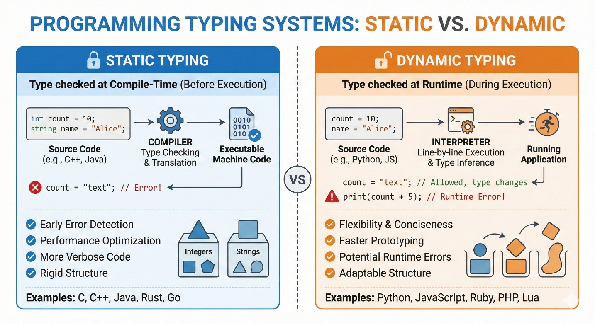

**Comparative Summary of Dynamic and Static Typing**

|  |  |  |
| --- | --- | --- |
| **Feature** | **Static Typing (e.g., C, Java, C#)** | **Dynamic Typing (e.g., Python, JavaScript)** |
| *Type Checking Timing* | Occurs at compile-time before the program runs. | Occurs at run-time while the program is executing. |
| *Variable Declaration* | Mandatory; types must be explicitly defined before use. | Not required; variables are created upon assignment. |
| *Reassignment Flexibility* | Illegal to assign a value of a different type to a variable. | Perfectly valid; variables can point to any data type at any time. |
| *Error Detection* | Errors are caught by the compiler during the build process. | Errors are identified only when the interpreter reaches the specific line. |
| *Memory Management* | Developer must pre-determine memory sizes (e.g., float vs. double). | Interpreter handles memory allocation and object tracking automatically. |
| *Execution Speed* | Generally faster due to pre-run optimizations. | Generally slower because the system must inspect objects at run-time. |
| *Development Speed* | Slower; involves a "compile-fix-compile" cycle. | Faster; facilitates a rapid "edit-test-debug" cycle. |

**Q9:** Differentiate procedural and object-oriented programming.

**Ans:**

Procedural programming and object-oriented programming (OOP) represent two fundamental approaches to organizing software logic and structure. While both methodologies aim to solve computing problems, they differ significantly in their philosophy, data handling, and extensibility.

**Core Philosophy and Structure**

The primary difference between the two lies in how a program is divided and executed.

* **Procedural Programming:** This approach follows a **top-down** methodology where a program is divided into small, manageable parts called functions. It is fundamentally based on the concept of a sequence of steps or a "procedure" to be followed to reach a result. In this paradigm, the **function** is considered more important than the data it processes. Historically, languages like C utilized this approach to organize code into a series of top-down functional calls.
* **Object-Oriented Programming (OOP):** OOP follows a **bottom-up** approach where the program is divided into small parts called objects. These objects act as containers that encapsulate both data and the methods (functions) that operate on that data. Unlike procedural programming, OOP treats **data** as more important than the individual functions. Python borrowed these concepts largely from C++.

**Data Management and Security**

How data is protected and accessed is a major point of divergence between the two paradigms.

* **Data Hiding and Security:** Procedural programming does not have a proper mechanism for hiding data, which generally makes it less secure. Because functions operate globally on data, it is difficult to restrict access. Conversely, OOP provides robust **data hiding** through encapsulation, making it significantly more secure. It utilizes **access specifiers** such as private, public, and protected to control which parts of a program can interact with specific data.
* **Encapsulation:** In OOP, data and methods are grouped together within classes. This allows the internal state of an object to be "private" (often indicated in Python with a leading underscore) while providing specific "getters" and "setters" or properties to safely interact with that data.

**Flexibility and Code Reuse**

Maintenance and the ability to extend code are areas where OOP offers distinct advantages in complex systems.

* **Extensibility:** In procedural programming, adding new data and functions is not easy and often requires significant rewriting of existing code. OOP makes adding new data and functions much easier because of its modular nature.
* **Inheritance:** A unique feature of OOP is inheritance, where a **subclass** (child) can inherit the attributes and methods of a **superclass** (parent). This allows developers to modify or specialize a program’s behavior by adding new components rather than rewriting existing ones.
* **Overloading and Polymorphism:** Procedural programming generally does not support **overloading**, which is the ability to use the same operator or function name for different types of data. OOP supports both operator and function overloading, allowing objects to respond to built-in operations (like addition or slicing) in custom ways defined by the programmer.

**Real-World Modeling**

The paradigms differ in how they represent logic relative to the physical world.

* **Logic Representation:** Procedural programming is often described as being based on the "unreal world," focused purely on the logical steps of the computer. OOP is based on the "real world," allowing programmers to model physical objects—such as a tire, a car, or a storage tank—as specific class instances. This makes it easier for developers to conceptualize complex systems.

**Python’s Multi-Paradigm Approach**

It is important to note that Python is a **multi-paradigm** language. It allows developers to use procedural techniques (functions) or object-oriented techniques (classes) as they see fit. While functions are excellent for repeating specific tasks without copying and pasting code, classes provide a powerful way to organize related code blocks and data into cohesive structures. A developer can even mix both styles within the same program to achieve the best balance of simplicity and power.

**Summary**

In practice, many languages (like Python and C++) support both styles. You can write procedural code in Python, or use its full object-oriented features. The choice depends on the problem domain and design preferences.

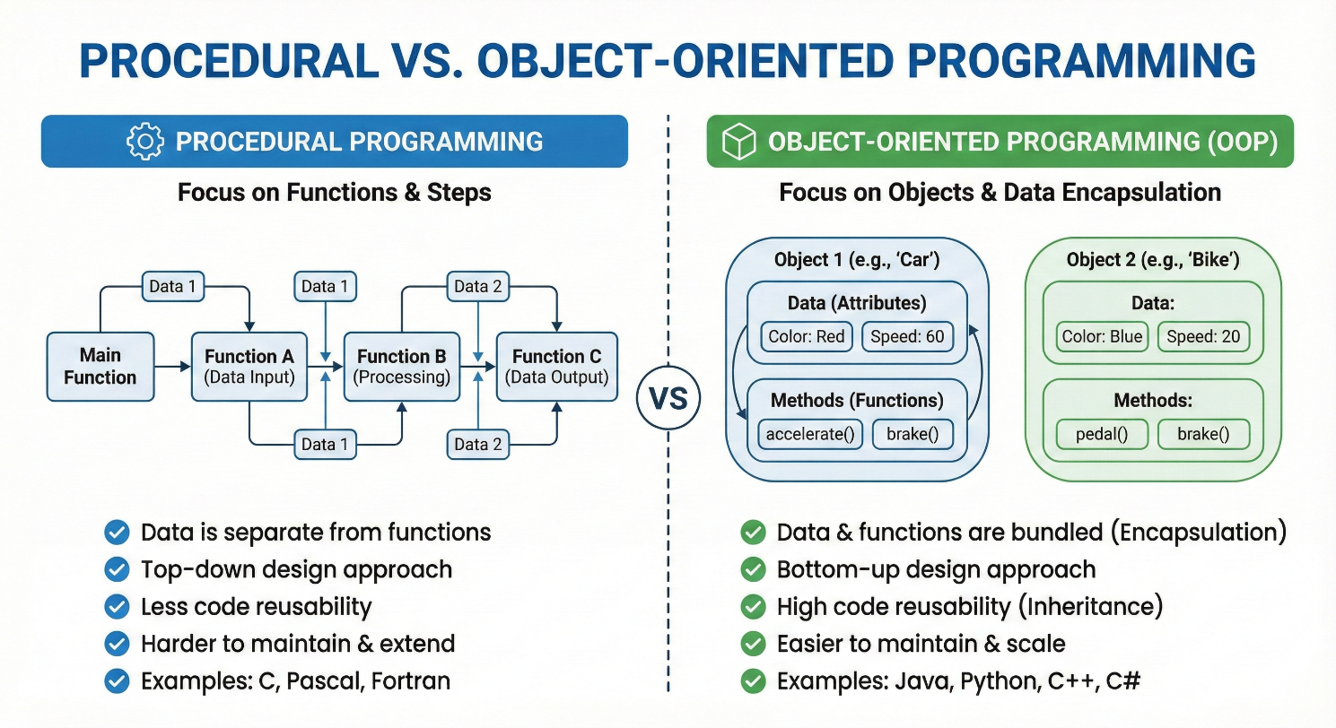

**Key differences:**

* **Structure:** Procedural divides a program into functions; OOP divides a program into classes/objects.
* **Data Handling:** Procedural code passes data between functions (no inherent data hiding). OOP encapsulates data within objects, allowing abstraction and hiding of internal state.
* **Approach:** Procedural is top-down (solve problem step by step); OOP is bottom-up (build objects that interact).
* **Features:** OOP supports inheritance and polymorphism (code reuse through class hierarchies), whereas pure procedural programming has no native inheritance.
* **Use Cases:** Procedural style can be simpler for small or straightforward tasks, while OOP scales better to complex systems by modeling real-world relationships.

**Conclusion:**

Python is an exceptionally powerful and popular tool because it prioritizes **developer efficiency** and **human readability** over complex machine-level syntax. Its "Elegant Simplicity" allows programmers to accomplish tasks with **3 to 5 times less code** than Java and **5 to 10 times less code** than C++.

As a **general-purpose language**, Python is incredibly versatile, powering everything from web development and data science to game design and the Internet of Things (IoT). Because it is an **interpreted language**, it skips the time-consuming compilation process, allowing for a rapid **"edit-test-debug"** cycle that saves significant development time.

Python’s status as a **"glue language"** makes it ideal for integrating disparate systems and components written in different languages like C, C++, or Java. Furthermore, its **dynamically typed** nature and **automated memory management** free the programmer from managing low-level container sizes and manual garbage collection. Supported by a **massive standard library** and over 150,000 third-party packages, Python provides the "building blocks" to develop almost any application "right out of the box".

